**Exercise 1: Configuring a Basic Spring Application**

**Scenario**: Your company is developing a web application for managing a library. You need to use the Spring Framework to handle the backend operations.

**Steps**:

1. Set Up a Spring Project:

* Create a Maven project named LibraryManagement.
* Add Spring Core dependencies in the pom.xml file.

2. Configure the Application Context:

* Create an XML configuration file named applicationContext.xml in the src/main/resources directory.
* Define beans for BookService and BookRepository in the XML file.

3. Define Service and Repository Classes:

* Create a package com.library.service and add a class BookService.
* Create a package com.library.repository and add a class BookRepository.

4. Run the Application:

* Create a main class to load the Spring context and test the configuration.

**IMPLEMENTAION:  
  
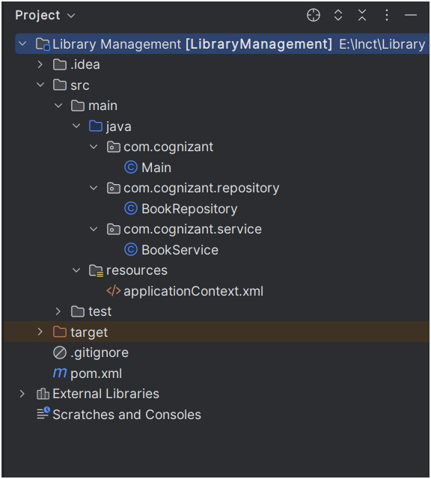**

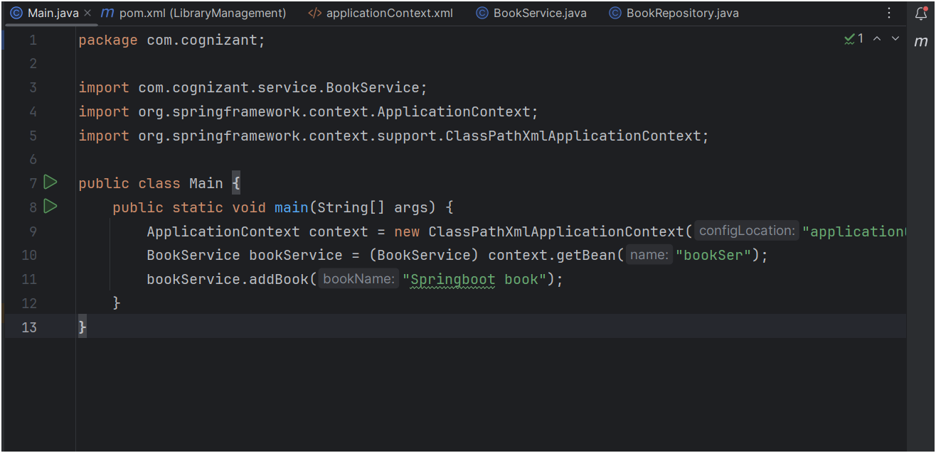

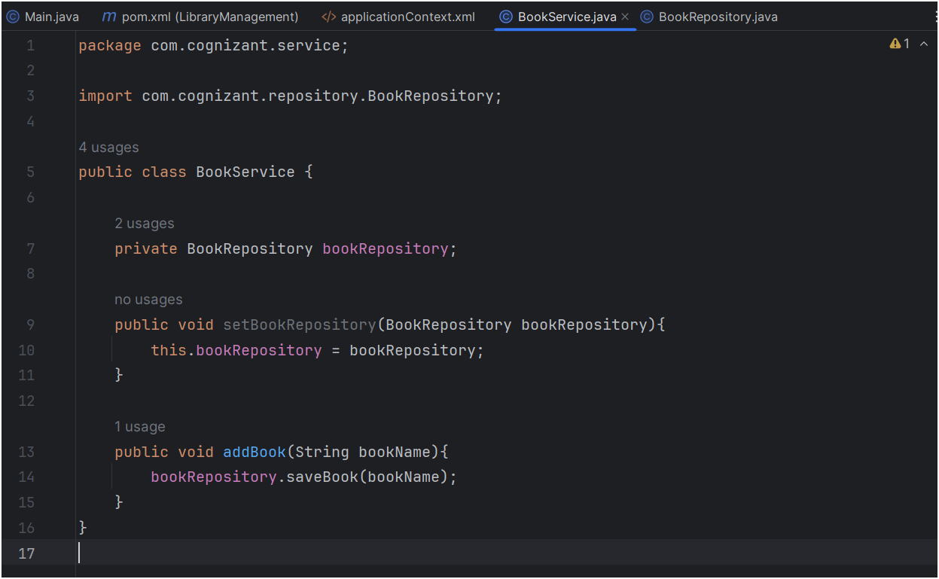

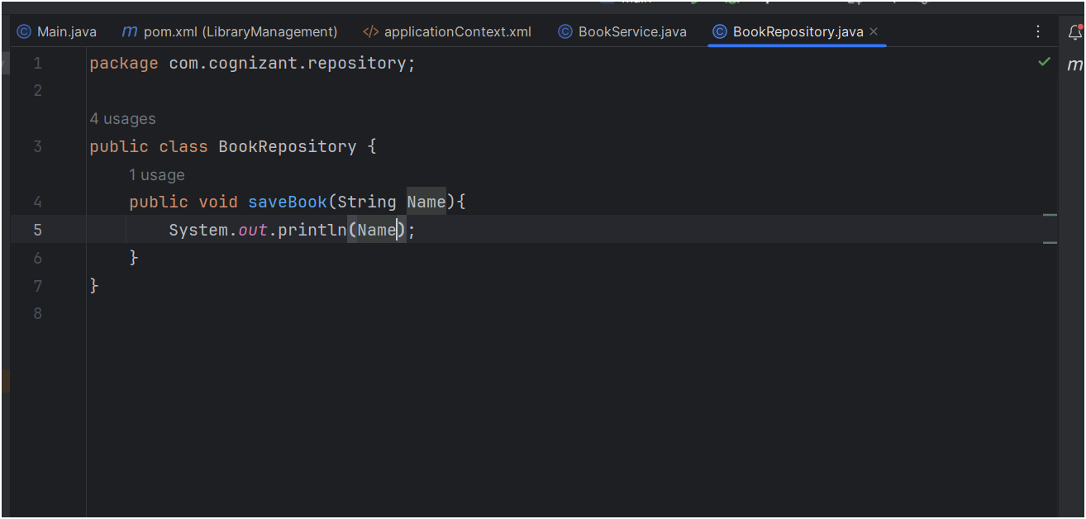

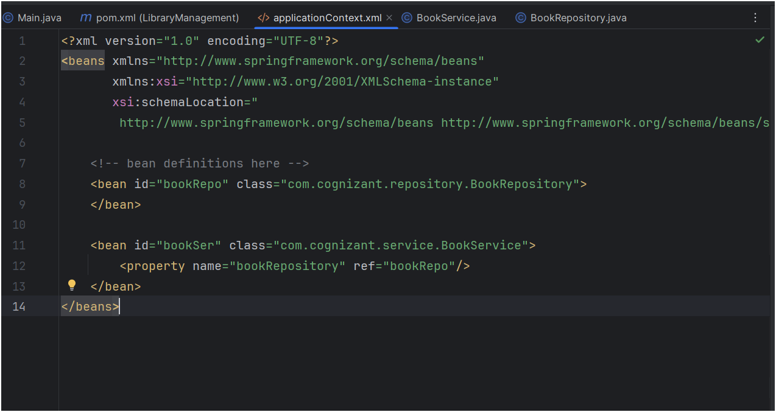

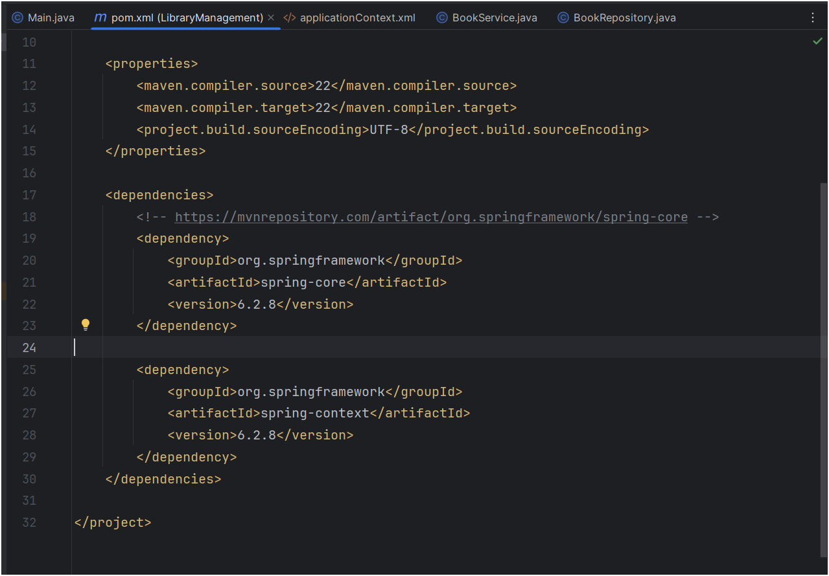

OUTPUT :  
  
